**Functionality Guide**

**Course: CST8285-311**

**Assignment2 – ABC Grocery**

**Group: #16**

**Member: Shing Kwan Chow, Chi Kin Choi**

# Introduction

Welcome to ABC Grocery. Quality products at everyday low prices – that’s the promise we made when we started ABC, and it’s as true today more than 10 years later. We consider it both our mission and our privilege to give Canadians access to the products they need at the prices they can afford, both in stores and online at Abc.ca.

# Homepage

You can use the navigation bar to go to the “Shop” page for shopping, “About US” to see our story, “My Orders” to check the orders you have placed, “Log out” to logout your existing account, and the shopping cart icon to check what items you have added to the shopping cart.

(Please note that you have to login first to see the above options. If you have not logged in, you will have a navigation bar that looks like the below one)

# About Us Page

To view our company overview regardless of whether you have signed in or not.

# Help Page

It can be accessed at the footer. It contains information about your purchase concerning delivery, cancellation and promotion.

# Term of Use Page

It can be accessed at the footer. It contains the terms of use of the website.

# Sign in Page

If you are not signed in, you will see a “Sign in” option on the navigation bar.

Once you are inside, existing customers can input their username and password to login.

If a wrong username or password is provided, a message will be prompted to warn the customer.

If the correct username and password are provided, you will be redirected to the homepage.

# Registration Page

It can be accessed from the “New Customer? Register Here!” message on the “Sign in” page.

Potential customers should provide their email address, username, password, and agreement to our terms and conditions in order to register as customers.

In addition, customers need to obey the constraints set on the registration information, as seen above. Once you register successfully, a success message will be shown.

# Shop Page

On the “Shop” page, customers can add their favorite products to their shopping cart.

**Filter option**

Allows customers to filter products by category.

**Search box**

Allows customers to search products by name, even using partial keywords.

**Clear all search button**

Allows customers to clear their search criteria.

**Add to Cart button**

Allows customers to add items to the shopping cart.

# Shopping Cart Page

This page can be accessed by clicking on the shopping cart icon (it only appears when customers are signed in).

**Purchase Now Button**

Allows customers to place their orders immediately.

**Clear the Shopping Cart Button**

Allows customers to clear their shopping carts’ items.

# My Order Page

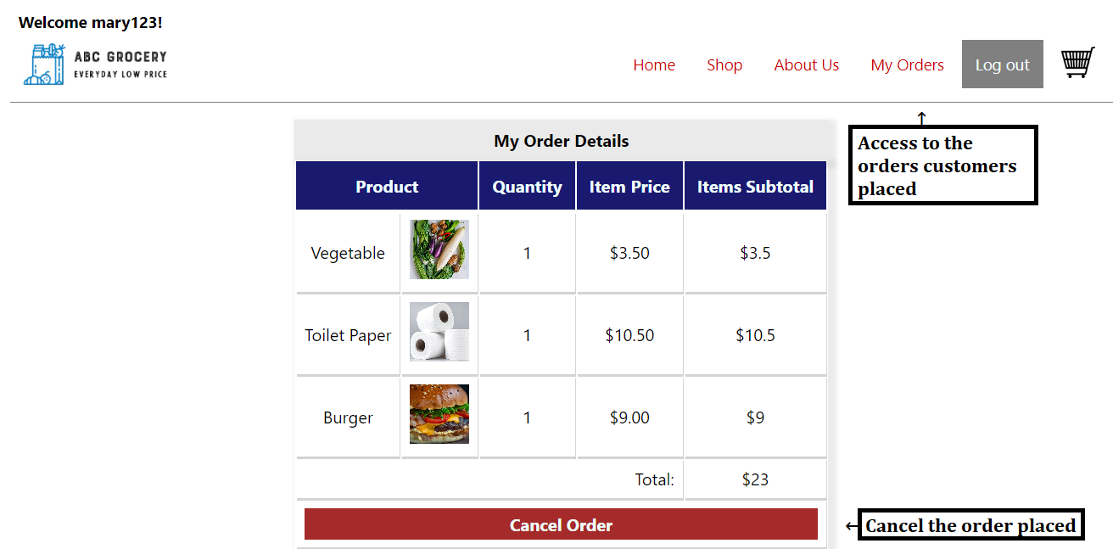

The “My Orders” page can be accessed on the navigation bar. There, you can check the orders you have placed.

**Cancel Order Button**

Allows customers to cancel their orders placed.

# Log out

Customers can log out by clicking the “Log out” button on the navigation bar. Once logged out, customers will be redirected to the homepage.